# **Documentation: Upgrading or Resetting Your Android App Signing Key**

This document outlines the process for upgrading or resetting the app signing key for an Android app on the Google Play Store. This process is necessary if you’ve lost access to your signing key, your key has been compromised, or you want to use a new signing key for your app.

## **1. Upgrading Your App Signing Key**

If you need to upgrade the app signing key for your app, follow these steps:

### **Step 1: Open Google Play Console**

1. Go to the Google Play Console.
2. Select the **app** for which you want to upgrade the app signing key.
3. Navigate to **Test and release > Setup >App Integrity > App signing**.  
   Alternatively, you can access this page via **Test and release > App integrity**. The App Integrity page contains signing services that ensure your app’s integrity during the release process.

### **Step 2: Request Upload Key Reset**

1. In the **Upgrade your app signing key** section, click on **Request Upload Key reset**.  
   This action starts the process of resetting your app signing key.

### **Step 3: Select the reason for resetting the key**

1. I lost my upload key
2. Developer with access to the Keystore as left my company
3. My upload key has been compromised
4. I forgot the password to my keystore
5. Others

Select an option to reset the app signing key from the above.

**Step 4: Generate new upload key**

A new keystore bcbsla_release.jks file has been generated.

**Step 5: upload the .PEM file generated from your upload key certificate.**

* We can generate the .PEM file using keystore explorer or using the .jks command.

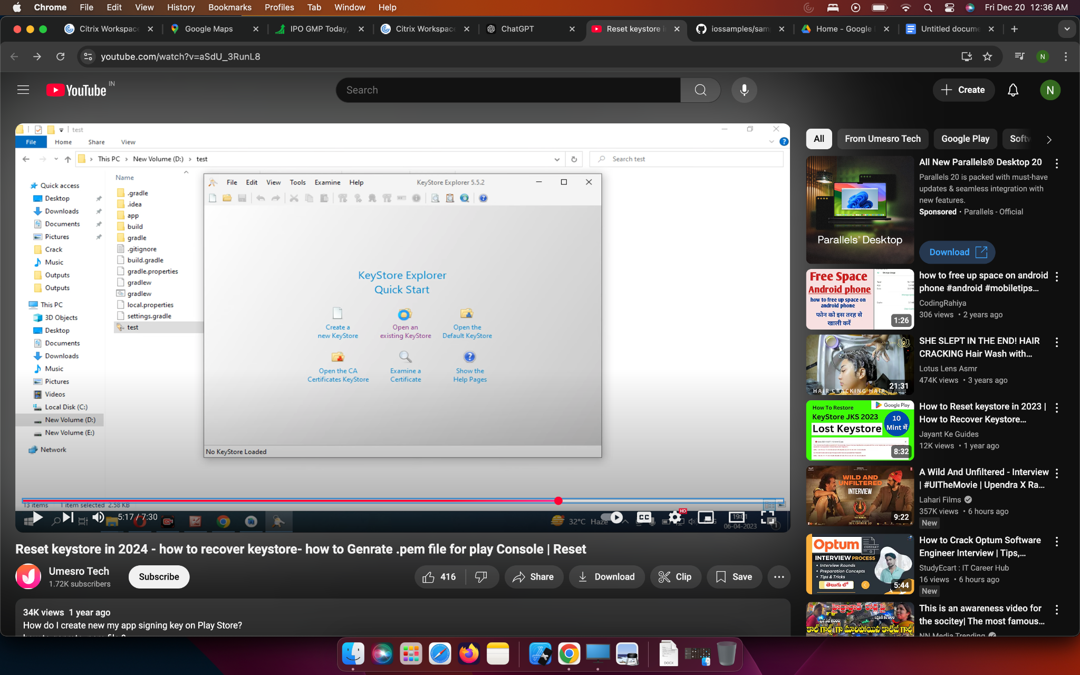

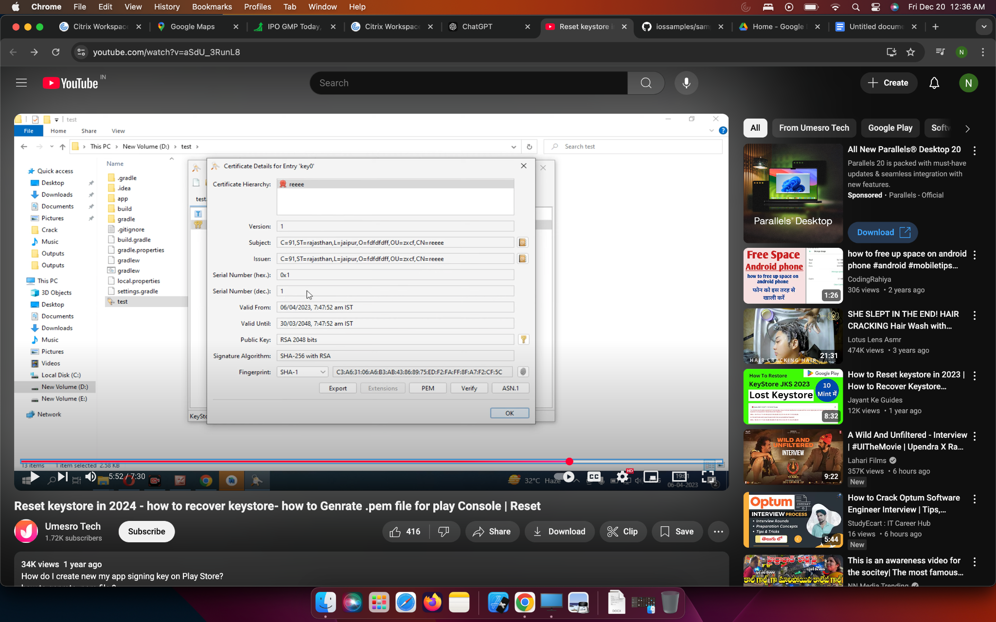

**Step 6: Request**

1. After clicking on the request button we will receive an email in 2-3 days for an update in the playstore.
2. Once the reset request is initiated, **Google Play support** will assist in registering a new upload key for your app.
3. After the support team registers the new key, you will receive an email and inbox message notifying you of the key reset. The message will contain instructions for the next steps.